### Cupid's Torus Heart for Valentine's Day

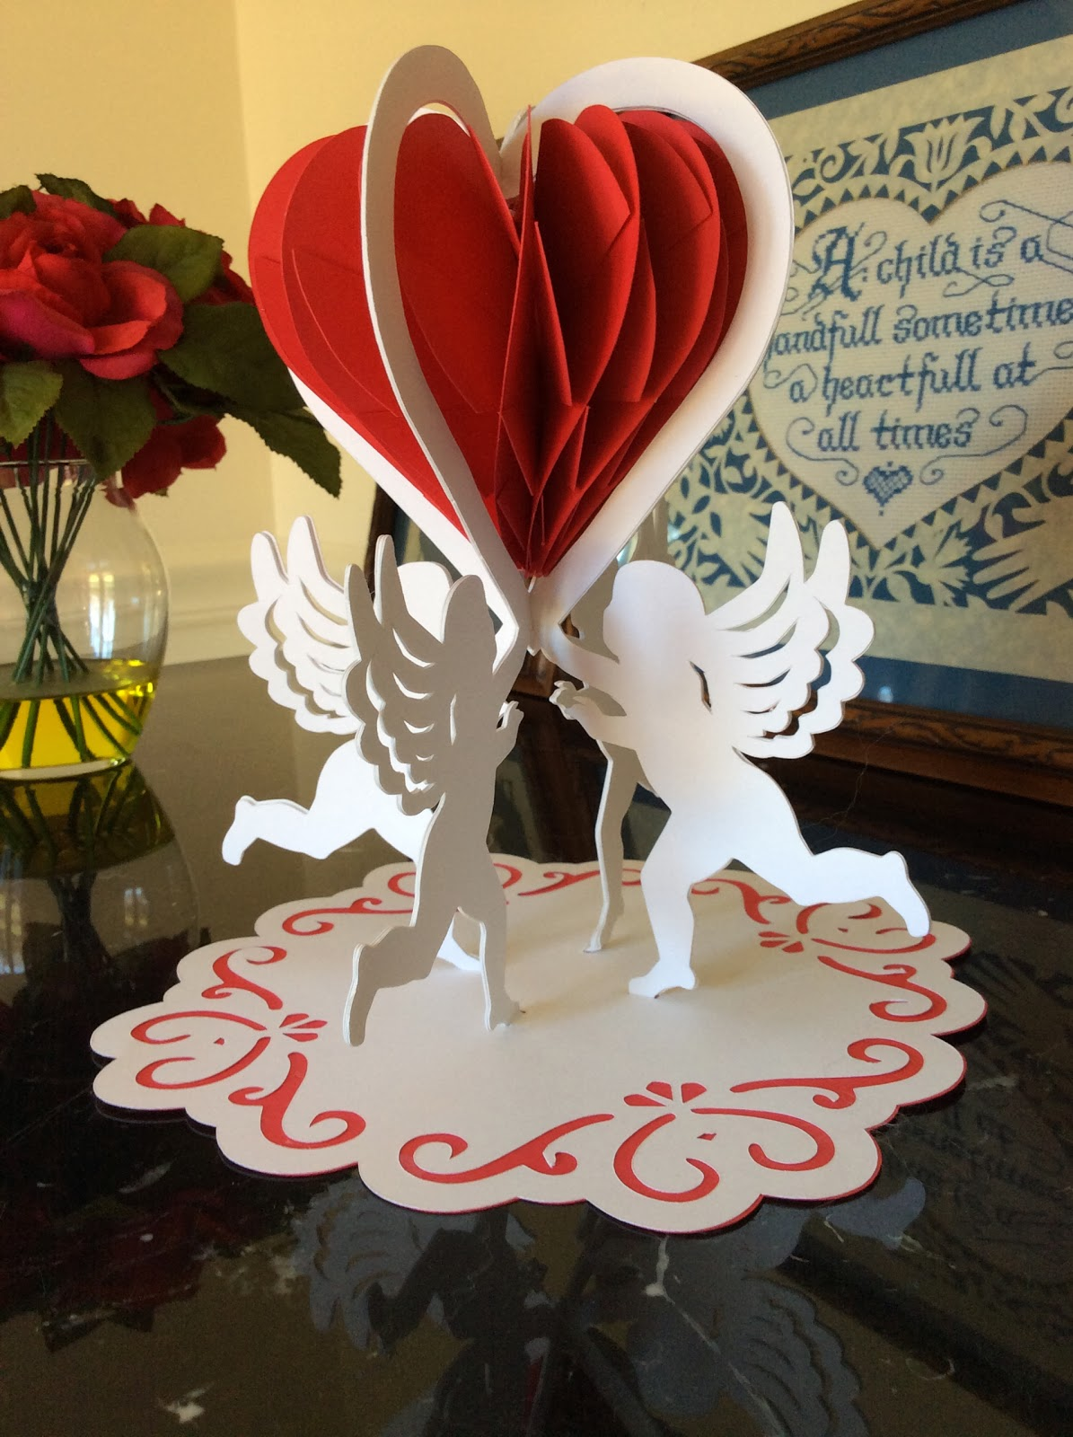

A Torus Heart Valentine Decoration

A torus heart and cupids are the epitome of Valentine's Day. I love the way that the cupids are holding the heart. The red torus heart is floating in the center of the structure. The weight of the torus heart was a factor in using five layers of cardstock glued together. I think that you might be able to obtain the same thickness by sandwiching chipboard between two layers of cardstock. However, I have not tried this because I cut the cupids a few times and did not have to resort to chipboard. If you do use chipboard, please leave a comment and I will update this post with your recommendation.

I put a drop of glue at the top and bottom of the heart torus to keep the heart from expanding in the middle. Use the directions from the pumpkin torus to make the torus heart <http://papercraftetc.blogspot.com/2013/10/a-honeycomb-pumpkin-decoration-for-fall.html>and the directions from the previous post to make the base.  
<http://papercraftetc.blogspot.com/2014/01/a-paper-sliceform-heart-table-decoration.html>

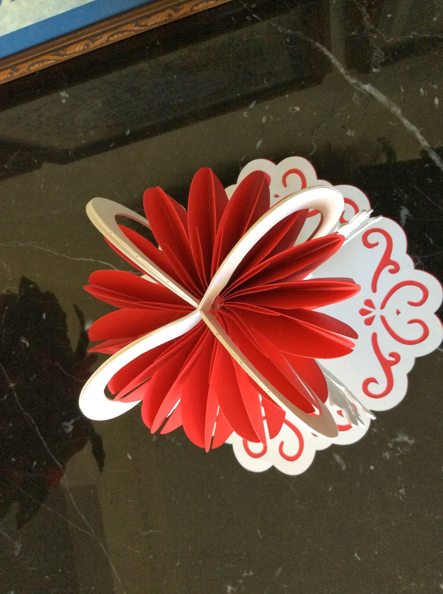

A View from above.

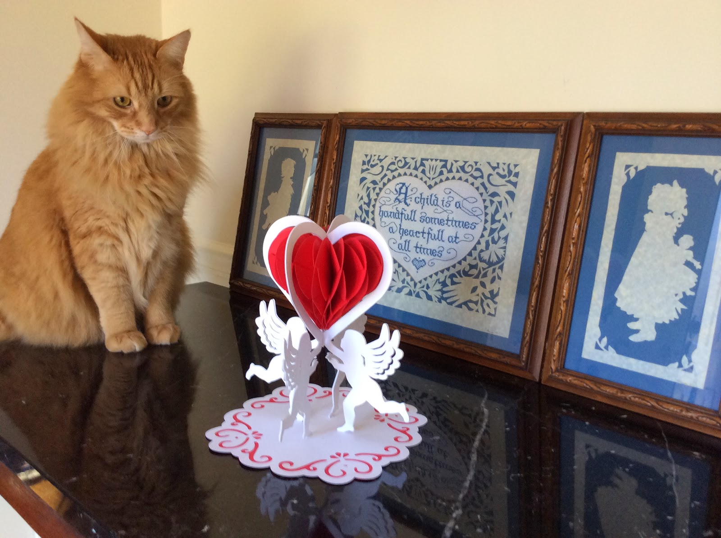

Melvin admiring my Valentine's decoration.

The framed pictures in the photo above represent the beginning of my paper fascination. I created them over 25 years ago.